
Help and support resources with retention labels
We have put this document together providing a compilation of help resources one can use for troubleshooting, advice, feed information to the product group, community postings and guides on how to deploy. The list is inclusive of official Microsoft documentation, training, and community-based medians for getting answers to known issues and submitting suggestions for the next release.

Online Help
The M365 Security and Compliance team at Microsoft have many avenues for consuming documentation and searching for online help. Review all the links below for your applicable question or need.

Online Reference material

MS Official Documentation
Getting Started with sensitivity labels is a starting point for all who are new to Microsoft Information Protection.
https://aka.ms/MIPC/GettingStarted

Microsoft 365 Compliance Documentation is the one stop you need to understand all M365 has to offer and the how-to of each solution.
https://aka.ms/mipcdocs
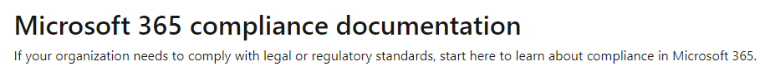

Microsoft Licensing Information to review all features available in M365 along with common questions answered.
https://aka.ms/MIPC/licensing
https://aka.ms/MIPC/MIPlicensing
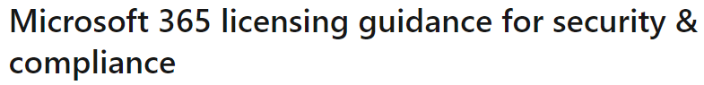

White Papers are a collection of best practices and guidance from our interaction with customers.
https://aka.ms/MIPC/DataClassification
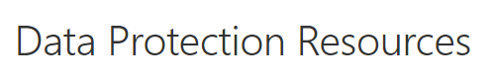

Technical Support
Microsoft Knowledge Base
https://support.microsoft.com/en-us

Free Option include the ability to use the Get Help app (first image) or contact support via a browser (second image).
https://support.microsoft.com/en-us/contactus/

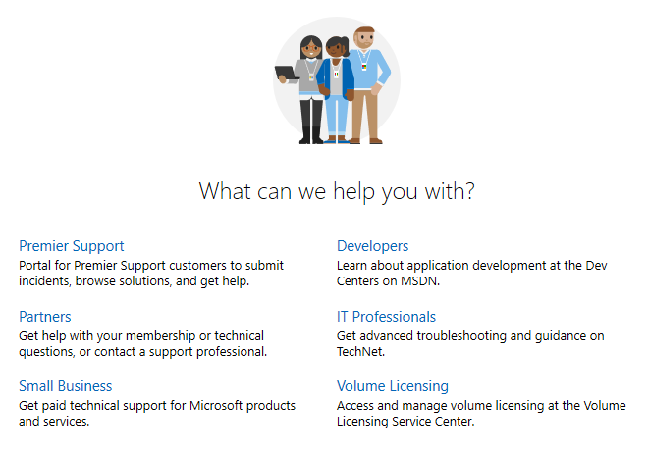

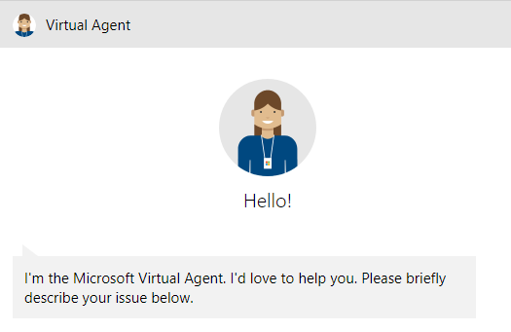

Paid Option provides assigned resources possibly via Premier Support for Enterprise. https://www.microsoft.com/en-us/msservices/premier-support
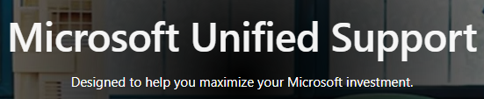

Microsoft Community
Security (protection) & Compliance UserVoice forum is a community-based site that allows for searching of and submitting your vote for other members ideas. The feedback is directed into product engineering and evaluated during release cycles make the products better.
https://aka.ms/compuv
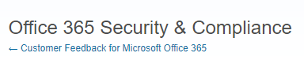

Microsoft Information Protection Team Yammer channel.
https://aka.ms/mipc/askmipteam
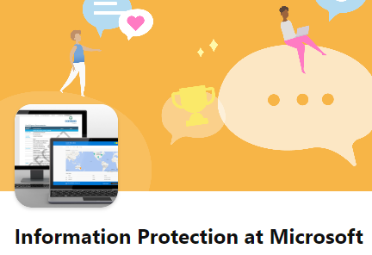

Microsoft Information Protection (MIP) UserVoice forum to log all feedback on feature requests, product ideas, and unexpected results.
https://Aka.ms/mip/uservoice

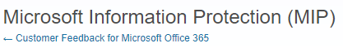

Microsoft Information Protection and Compliance Resources is proctored by the Customer Experience team that engages with the largest companies delivering guidance for deployment of information protection and compliance solutions within M365.
https://aka.ms/mipc/techcommunity
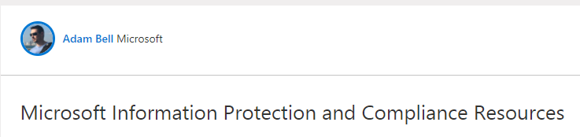

Microsoft Security and Compliance Technical Community latest news and engagement on all things training and top of mind with the community.
https://techcommunity.microsoft.com/t5/microsoft-security-and/bd-p/SecurityandCompliance

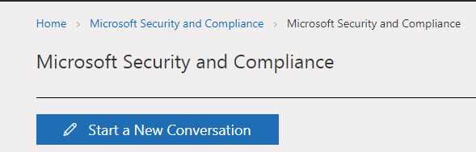

Webinars are online training presented by the CxE team.
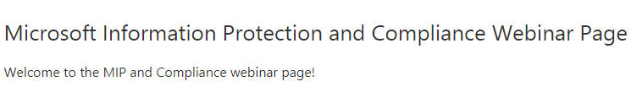
https://aka.ms/MIPC/Webinars.

Blogs are a tool for consuming our most recent release and leaving valuable feedback for the CxE team.
https://aka.ms/CompBlog

Contact US
Follow us on Twitter for latest on things related to M365 Security and Compliance.
@MipNews
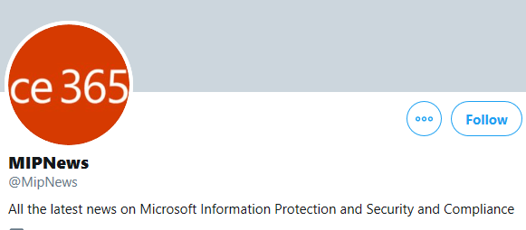

Email the CxE team with any suggestions or feedback that does not fit into other channels. If related directly to the product, please direct comments to UserVoice. Should you have feedback on webinars, blogs, or ideas for additional training, do share at the address below. All support issues should be directed through official channels of Premier support, or community forums.
mipsccxe@microsoft.com

